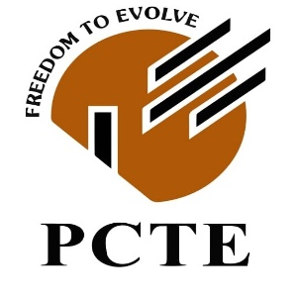
PCTE INSTITUTE OF ENGINEERING AND TECHNOLOGY

B.TECH COMPUTER SCIENCE ENGINEERING (CSE) 7th SEMESTER

PROJECT-II

BTCS 703-18

PROJECT-II SYNOPSIS

TOPIC: SMART CAMPUS APP PROMOTION
NAME: KETANJEET SINGH CHANNA AND NITIN KUMAR
CLASS: B.TECH CSE 2023 A / BJAMC 2024
ROLL NUMBER: 2329362 / 2446769
CONTACT NUMBER: +91-8837776049 / +91-7986315772
E-MAIL ADDRESS: ketanchanna8865@gmail.com / nv11572@gmail.com

SUBMITTED TO: MS. PRATIKSHA BAGGA
CONTACT NUMBER: +91-8968355877
E-MAIL ADDRESS: pratikshabagga@pcte.edu.in

__________________________
TEACHER’S SIGNATURE

- INTRODUCTION TO THE TOPIC:

The rapid advancement of digital technologies has transformed the way educational institutions deliver academic and administrative services. However, many colleges still rely on fragmented systems for communication, event management, and student engagement, resulting in inefficiencies and limited collaboration. NEXUS is a Smart Campus mobile application designed to provide a unified digital platform that integrates essential campus services into a single, user-friendly interface. The application facilitates seamless communication among students, faculty, and administrators while improving accessibility to academic resources and institutional updates. Additionally, it promotes inter-college collaboration by enabling students to connect, share knowledge, participate in events, and work on collaborative projects. The project aims to support digital transformation in higher education by creating a connected, efficient, and student-centric campus ecosystem.

- PROBLEM STATEMENT:

Educational institutions often rely on multiple disconnected platforms for academic communication, event management, notices, attendance, and student services, leading to fragmented information flow and reduced operational efficiency. Students frequently face difficulties in accessing timely updates, participating in campus activities, and collaborating with peers across departments or institutions. Additionally, the absence of a unified digital ecosystem limits opportunities for academic networking, project collaboration, and knowledge sharing. Existing systems primarily focus on administrative functions while offering limited support for student engagement and inter-college connectivity. Therefore, there is a need for an integrated Smart Campus platform that centralizes campus services, enhances communication, and fosters collaboration among students, faculty, and educational institutions through a secure and user-friendly mobile application.

- AIM OF THE PROJECT:

The increasing digitalization of higher education has created a demand for an integrated platform that streamlines academic, administrative, and communication-related services within educational institutions. Existing campus management systems are often fragmented, making it difficult for students to access timely information, engage in campus activities, and collaborate with peers across different institutions. There is a need for a centralized solution that enhances communication, improves accessibility to campus resources, and promotes student engagement through a unified digital ecosystem.

The primary aim of this project is to develop NEXUS, a Smart Campus mobile application that integrates essential campus services into a single, secure, and user-friendly platform. The application seeks to facilitate seamless interaction among students, faculty, and administrators while encouraging inter-college collaboration, knowledge sharing, and participation in academic and extracurricular activities. By supporting digital transformation in educational institutions, the project aims to create a connected, efficient, and student-centric campus environment.

- OBJECTIVES OF THE PROJECT:

The primary objectives of the proposed NEXUS – Smart Campus web application are as follows:

- To develop a centralized web-based platform that integrates essential campus services into a single digital system.

- To enhance communication between students, faculty, and administrators through real-time announcements and notifications.

- To provide seamless access to academic information, including timetables, attendance, assignments, events, notices, and other institutional services.

- To improve student engagement by providing a unified platform for clubs, events, competitions, and extracurricular activities.

- To promote digital transformation by replacing fragmented campus management systems with a secure, scalable, and user-friendly web application.

- To ensure efficient data management, secure user authentication, and role-based access control for students, faculty, and administrators.

- PROJECT SCOPE AND ANALYSIS:

The scope of NEXUS – Smart Campus is to develop a centralized web-based platform that streamlines academic, administrative, and collaborative activities within educational institutions. The system will provide role-based access for students, faculty, and administrators, enabling efficient management of academic information, campus announcements, events, attendance, assignments, and institutional resources through a unified interface.

The platform will also facilitate inter-college collaboration by allowing students from different institutions to connect, participate in discussions, share knowledge, collaborate on projects, and engage in academic and extracurricular activities. In addition, the project includes the development of a promotional and communication strategy to encourage user awareness and adoption within educational institutions. The proposed system is intended to improve communication, accessibility, operational efficiency, and student engagement while supporting the digital transformation of campus environments.

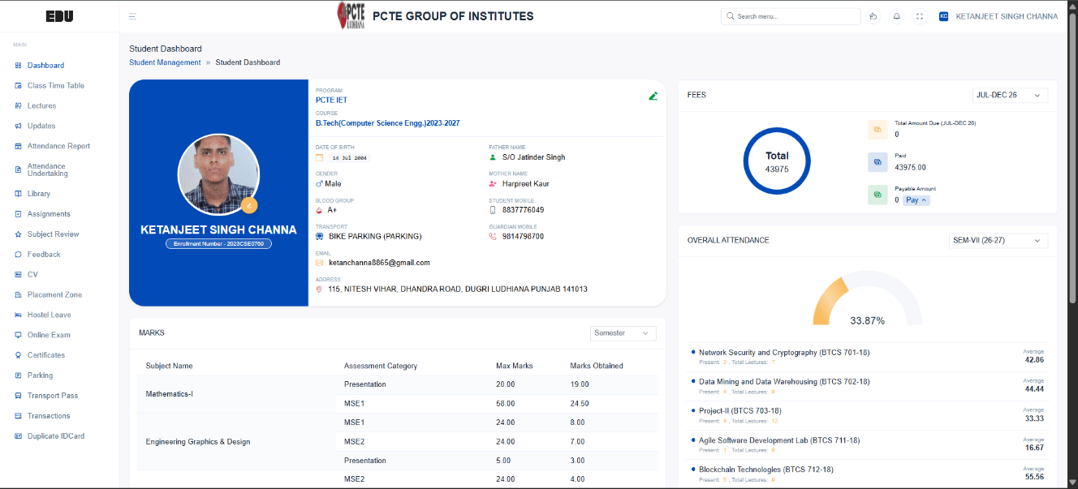
- LITERATURE SURVEY / EXISTING SYSTEM:

Most educational institutions currently utilize Enterprise Resource Planning (ERP) systems to manage academic and administrative operations. The existing system provides functionalities such as student profile management, attendance tracking, timetable scheduling, fee management, examination records, assignment updates, library services, and academic notifications through a centralized web portal. These systems have significantly improved institutional record management by digitizing routine academic processes and reducing manual documentation.

However, the existing system primarily focuses on administrative operations and offers limited support for student engagement, collaboration, and interaction beyond institutional boundaries. Communication is generally restricted to notices and academic updates, while opportunities for project collaboration, discussion forums, innovation communities, and inter-college networking remain limited. Furthermore, the user experience is largely information-centric rather than engagement-oriented, reducing active participation in campus activities.

Limitations of the Existing System:

- Primarily designed for administrative and academic record management.

- Limited interaction between students and faculty beyond official communication.

- No dedicated platform for inter-college collaboration and networking.

- Absence of discussion forums and project collaboration features.

- Limited support for student clubs, innovation communities, and extracurricular engagement.

- Restricted opportunities for knowledge sharing across institutions.

- User interface focuses on information access rather than interactive student engagement.

- RESEARCH GAP:

Existing campus management systems primarily focus on digitizing academic and administrative operations such as attendance management, fee records, examination details, timetables, and student information. While these systems improve operational efficiency, they offer limited support for student engagement, collaborative learning, and inter-institutional interaction. Features such as discussion forums, project collaboration, innovation communities, event networking, and cross-campus communication are either absent or minimally integrated. Additionally, the existing platforms are largely information-centric and do not provide an interactive environment that encourages active participation and knowledge sharing. Therefore, there is a need for a unified web-based platform that combines campus management with collaborative and engagement-driven functionalities. The proposed NEXUS – Smart Campus system addresses this gap by integrating academic services with communication, collaboration, and networking features, thereby creating a more connected, interactive, and student-centric digital campus ecosystem.

The existing system lacks the following key capabilities:

- Centralized access to all campus services through a single, user-friendly interface.

- Interactive student engagement through clubs, events, announcements, and campus activities.

- An enhanced user experience with a modern, intuitive, and easily accessible dashboard for all stakeholders.
- PROPOSED SYSTEM:

The proposed system, NEXUS – Smart Campus, is a comprehensive web-based platform designed to integrate academic, administrative, financial, communication, and AI-enabled services into a unified digital ecosystem. The system aims to simplify campus operations while enhancing communication, accessibility, and student engagement through a centralized and user-friendly interface. It provides secure, role-based access for students, faculty, and administrators, enabling efficient management of academic activities, campus resources, financial transactions, and institutional services. By incorporating intelligent automation, real-time communication, and advanced analytics, NEXUS seeks to transform conventional campus management into a smart, connected, and technology-driven environment.

Core Modules of the Proposed System:

1. Smart Dashboard
Provides a personalized dashboard displaying next lecture schedules, class timetables, assignment deadlines, examinations, campus announcements, sports fixtures, upcoming events, quick notes, notifications, and personalized reminders.

2. Academic & Campus Management
Manages academic activities including attendance, timetable, assignments, examination schedules, study materials, digital notices, classroom availability, digital ID cards, hostel services, visitor passes, and campus resource management.

3. Communication & Collaboration
Facilitates seamless communication through campus-wide announcements, departmental notifications, discussion forums, student-faculty networking, project collaboration, feedback mechanisms, and secure internal messaging.

4. Event, Club & Promotion Management
Enables departments, clubs, and student societies to organize events, upload promotional banners, manage registrations, conduct digital club elections, broadcast announcements, and promote institutional activities across the campus.

5. Smart Services & Financial Management
Provides digital campus services including canteen management with online ordering and meal pre-booking, semester fee payments, examination fees, parking fees, event registration fees, transportation services with bus schedules, and secure digital transaction history.

6. AI-Powered Learning & Career Support
Integrates Artificial Intelligence to provide resume analysis, ATS evaluation, career recommendations, AI-powered chatbot assistance, document-based self-assessments, automated quiz generation, performance analysis, and personalized learning recommendations.

7. Campus Community & Safety
Supports student and faculty networking, alumni engagement, mentorship opportunities, digital certificate repository, emergency SOS services, campus-wide emergency broadcasts, incident reporting, and secure access to institutional resources.

8. Administration & Analytics
Provides administrators with centralized control over user management, departments, events, finances, permissions, reports, and institutional analytics. Interactive dashboards and graphical reports enable monitoring of attendance, financial transactions, event participation, student engagement, and overall system performance.

Key Features of NEXUS:

- Centralized Smart Campus Web Platform
- Role-Based Access for Students, Faculty & Administrators
- Personalized Smart Dashboard
- Academic & Administrative Management
- AI-Powered Learning and Career Assistance
- Smart Canteen with Digital Ordering
- Digital Payments & Transaction Management
- Event, Club & Election Management
- Student-Faculty Networking & Collaboration
- Hostel, Transport & Visitor Management
- Digital ID Cards & Certificate Repository
- Emergency SOS & Campus Alert System
- AI Chatbot for Campus Assistance
- Advanced Analytics & Reporting

- METHODOLOGY WORKFLOW:

The development of NEXUS – Smart Campus follows a systematic and user-centric approach to ensure efficient implementation, scalability, and ease of use. The platform is designed using a modular architecture where each component performs a specific function while seamlessly interacting with other modules. The system employs secure authentication, centralized data management, AI-powered services, and real-time communication to provide an integrated digital campus experience.

Initially, users register and authenticate themselves using their institutional credentials. Based on their assigned role (Student, Faculty, or Administrator), the system provides access to personalized dashboards and relevant services. Students can access academic information, participate in campus events, make online payments, interact with faculty, and utilize AI-powered learning tools. Faculty members can manage academic activities, communicate with students, publish notices, review feedback, and monitor classroom-related information. Administrators supervise the overall system by managing users, approving events, monitoring financial transactions, generating reports, and maintaining institutional data.

The platform integrates Artificial Intelligence to provide intelligent services such as resume analysis, AI chatbot assistance, document-based self-assessments, and personalized career recommendations. Real-time notifications ensure that users remain updated about lectures, examinations, assignments, campus events, transportation schedules, emergency alerts, and other institutional activities.

All system data is securely stored in a centralized database with role-based access control, ensuring data confidentiality, integrity, and availability. Analytical dashboards generate graphical reports that assist administrators in monitoring attendance, financial transactions, student engagement, and overall campus performance.

The overall development process follows the Agile Software Development Methodology, enabling iterative development, continuous testing, user feedback incorporation, and incremental enhancement of system functionalities.

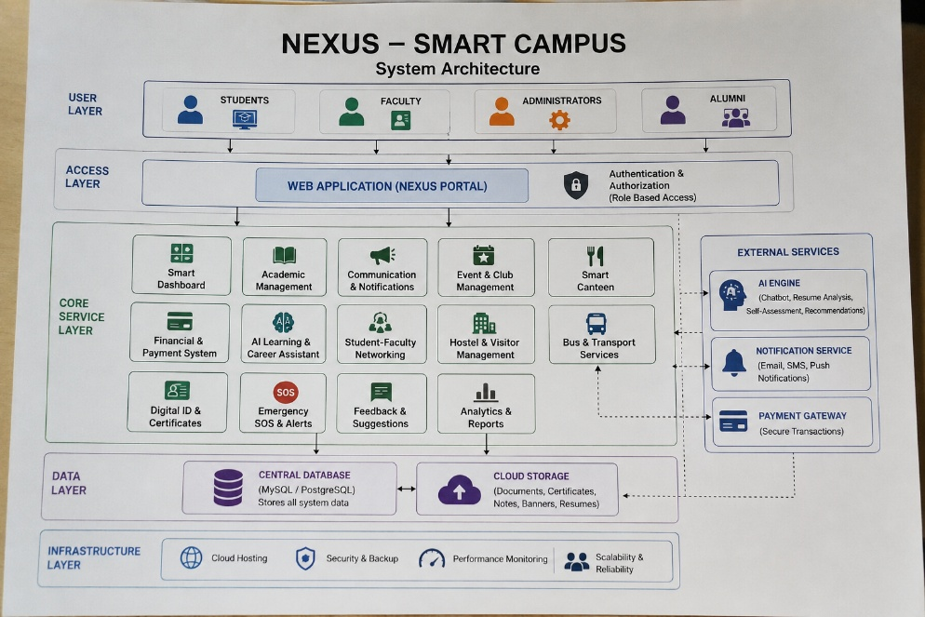
- SYSTEM ARCHITECTURE:
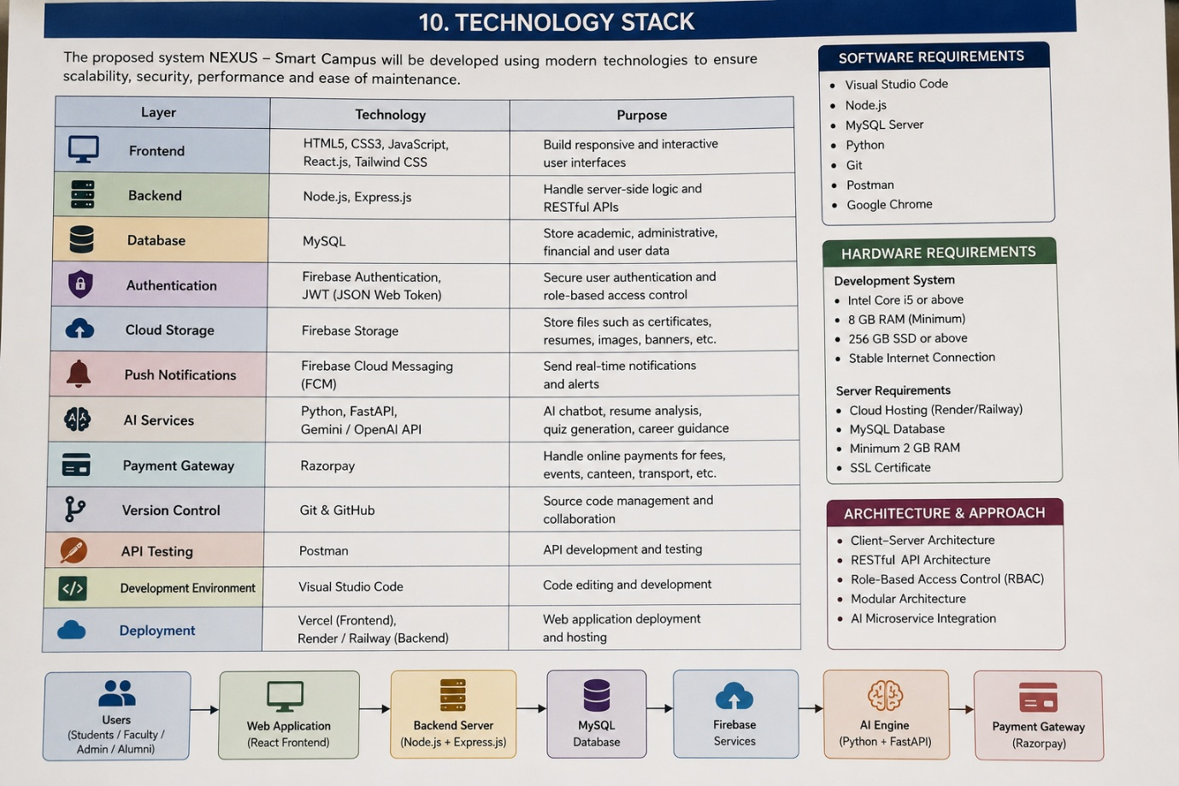
- TECHNOLOGY STACK:

- EXPECTED OUTCOMES:

The successful implementation of NEXUS – Smart Campus is expected to enhance the efficiency, accessibility, and overall digital experience within the institution by integrating academic, administrative, financial, and communication services into a single web-based platform. The system aims to reduce manual processes, improve collaboration among students, faculty, and administrators, and provide intelligent services through Artificial Intelligence.

The expected outcomes of the proposed system are:

- Development of a centralized Smart Campus platform for academic and administrative management.
- Improved communication among students, faculty, departments, and administrators through real-time notifications and announcements.
- Simplified management of attendance, timetables, assignments, examinations, and academic records.
- Secure digital payment system for semester fees, examination fees, canteen services, transportation, and event registrations.
- AI-powered services including resume analysis, chatbot assistance, self-assessment, and career recommendations.
- Enhanced student engagement through clubs, events, digital elections, and campus networking.
- Efficient hostel, transportation, visitor pass, and campus facility management.
- Secure digital storage of certificates, documents, and institutional records.
- Interactive dashboards with analytical reports for attendance, financial transactions, student engagement, and institutional performance.
- Improved campus safety through emergency SOS alerts and campus-wide broadcast notifications.
- A scalable and secure platform capable of supporting future technological enhancements and increasing institutional requirements.

- ROLES AND RESPONSIBILITIES:

Student 1 – B.Tech (Computer Science & Engineering)
The B.Tech student will be responsible for the complete technical development and implementation of the NEXUS – Smart Campus platform.

Responsibilities
- Requirement analysis and system design
- Database design and management
- Frontend development (React.js)
- Backend development (Node.js & Express.js)
- REST API development and integration
- User authentication and role-based access control
- AI module integration (Chatbot, Resume Analysis, Self-Assessment)
- Smart dashboard implementation
- Payment gateway integration
- Notification system implementation
- Testing, debugging, deployment, and technical documentation

Student 2 – BJAMC (Bachelor of Journalism & Mass Communication)
The BJAMC student will be responsible for communication strategy, branding, digital content, and user engagement to enhance the usability and outreach of the platform.

Responsibilities
- Requirement gathering through user surveys and interviews
- Branding and identity development for NEXUS
- Content creation for announcements, notices, and campus news
- Design of promotional banners, posters, and multimedia creatives
- Event and campaign planning
- Club and society promotion
- User engagement strategy
- Alumni engagement content
- Feedback collection and user experience evaluation
- Presentation design, project documentation, and promotional materials

Collaborative Responsibilities
Both students will jointly contribute to the following activities:
- Project planning and requirement finalization
- Feature brainstorming and module design
- UI/UX review and improvements
- System testing and validation
- User acceptance testing (UAT)
- Final report preparation
- Project presentation and demonstration
- Future enhancement planning

- FUTURE SCOPE (FOR B.TECH):

The proposed NEXUS – Smart Campus platform has significant potential for future enhancement and expansion. As educational institutions continue to adopt emerging technologies, the system can be upgraded to provide more intelligent, automated, and personalized campus services. Future developments will focus on improving operational efficiency, enhancing user experience, and supporting smart campus initiatives through advanced digital technologies.

Future Enhancements
- Develop dedicated Android and iOS mobile applications for seamless access to campus services.
- Integrate IoT-enabled smart classrooms, smart attendance systems, and campus automation.
- Implement facial recognition and biometric authentication for secure attendance and campus access.
- Introduce AI-powered predictive analytics to identify students requiring academic support and improve institutional decision-making.
- Enhance the AI assistant with voice-based interaction, multilingual support, and personalized recommendations.
- Integrate Learning Management Systems (LMS) such as Moodle or Google Classroom for centralized digital learning.
- Expand transportation services with GPS-enabled live bus tracking and route optimization.
- Implement QR-based cashless campus services for canteens, libraries, hostels, and event registrations.
- Introduce Blockchain-based digital certificate verification to ensure secure, tamper-proof academic credentials.
- Develop an Alumni Mentorship Portal connecting current students with alumni for internships, career guidance, and placement opportunities.
- Integrate with national digital platforms such as DigiLocker and Academic Bank of Credits (ABC) for secure academic document management.
- Support inter-campus collaboration, enabling multiple institutions to communicate, organize joint events, and share academic resources through a unified platform.

- FUTURE SCOPE (FOR BJAMC):

The NEXUS – Smart Campus platform offers significant opportunities for enhancing campus communication, digital media, and student engagement. In the future, the platform can evolve into a comprehensive communication ecosystem that strengthens collaboration between students, faculty, alumni, and institutional stakeholders through innovative media strategies and digital content.

Future Enhancements:
- Develop an integrated Digital Campus Newsroom for publishing campus news, achievements, interviews, and success stories.
- Introduce live streaming of seminars, workshops, cultural events, and sports competitions.
- Expand the platform with podcasts, video blogs (vlogs), and multimedia storytelling to promote institutional activities.
- Integrate official social media channels for seamless sharing of events, announcements, and campaigns.
- Implement AI-powered content recommendations to deliver personalized news, events, and announcements.
- Establish an Alumni Engagement Portal for networking, mentorship programs, and sharing professional experiences.
- Develop digital marketing campaigns to improve student participation in academic, cultural, and extracurricular activities.
- Introduce multilingual content support to improve accessibility and communication among diverse student communities.
- Create an interactive Campus Magazine and Newsletter managed through the platform.
- Enhance public relations by enabling departments and student organizations to promote achievements, initiatives, and community outreach programs through a centralized digital communication platform.

From a BJAMC perspective, NEXUS – Smart Campus has the potential to become a comprehensive digital communication and media platform that strengthens institutional branding, promotes effective information dissemination, and encourages greater student participation. By integrating modern communication technologies and multimedia content strategies, the platform can foster a more connected, informed, and engaged campus community while supporting the institution's long-term digital transformation initiatives.

- CONCLUSION:

The proposed NEXUS – Smart Campus is a comprehensive web-based platform designed to modernize and simplify campus operations by integrating academic, administrative, financial, communication, and AI-powered services into a unified digital ecosystem. The system addresses the limitations of conventional campus management by providing a centralized solution that enhances accessibility, collaboration, and operational efficiency for students, faculty, administrators, and alumni.

By incorporating features such as a personalized smart dashboard, academic management, AI-based learning assistance, digital payments, smart canteen services, student–faculty networking, event and club management, hostel and transport services, emergency alert mechanisms, digital certificate repository, and analytical dashboards, the platform aims to create a connected and technology-driven campus environment. The integration of Artificial Intelligence further enhances the user experience through intelligent recommendations, automated assessments, resume analysis, and virtual assistance.

From a technical perspective, the project demonstrates the effective use of modern web technologies, cloud-based services, secure authentication mechanisms, and scalable system architecture to develop a reliable Smart Campus solution. Simultaneously, the collaboration with the BJAMC discipline strengthens the platform by incorporating effective digital communication, branding, content management, and user engagement strategies.

Overall, NEXUS – Smart Campus has the potential to significantly improve institutional efficiency, enhance student engagement, promote transparent communication, and support the digital transformation of educational institutions. The platform provides a scalable foundation for future technological advancements and serves as a step towards building intelligent, connected, and future-ready campuses.

